Name: _____________________________

**Midterm Study Guide**

*Complete the following*:

1. Compare and contrast longitude and latitude. What is the difference between Prime Meridian and Equator?
2. What is the most important rule to follow in the lab?

Follow all teacher instructions

1. What are contour lines, and how are they read on a Topographic map. Line on a topographic map
2. Identify the contour interval for the following Map. What is the highest point on this map? What is the highest possible point on this map? What is the difference between the highest point and the highest possible point and how do you know? The highest point is 40m, Highest possible is point is 49m due to the fact that the contour interval is 10.



1. Name the 3 rock types and how they are formed and classified.

|  |  |  |
| --- | --- | --- |
| **Igneous Rock** | **Sedimentary Rock** | **Metamorphic Rock** |
| Formed from cooling of Magma or lava  Classified by where they are formed.  (Intrusive or Extrusive) | Formed from compaction and cementation of sediments.  Classified by how/ what they are formed from  (Chemical and Clastic) | Formed from heat and pressure  Classified by their texture  (Foliated or Nonfoliated) |

1. Draw and identify all parts of the rock cycle and all the processes that go into it.
2. What is drives the Rock Cycle?

Sun and heat from Earth’s Interior

Sun- Drives processes for sedimentary rocks and some cooling of lava

Earth’s Interior- Drives Igneous and Metamorphic Rock Processes

1. State theory of plate tectonics.

The lithosphere is broken into plates that move like a rigid layer.

1. Complete the chart below

|  |  |  |  |
| --- | --- | --- | --- |
| **Plate Boundary** | **What it looks like** | **Actions** | **Where it can be found** |
| Transform Fault |  | Earthquakes | San Andreas Fault |
| O-O Divergent |  | Seafloor Spreading | Mid-Atlantic Ridge |
| C-C Divergent |  | Rift Valleys | East African Rift Valley |
| O-O Convergent |  | Subduction/ Trench  Earthquakes  Tsunami  Volcanic Island Arcs | The Aleutian Islands of Alaska |
| C-C Convergent |  | Mountain Building (Regional Metamophism) | Himalayas |
| O-C Convergent |  | Subduction/ Trench  Earthquakes  Tsunami  Continental Volcanic Arc | The Andes |

1. How oceanic lithosphere changes from mid ocean ridge to continental margin.

It gets older.

1. What an earthquake is and how it is measured

Rapid release of energy from rocks

1. What the movements that proceed and follow Earthquakes are.

Foreshocks and Aftershocks

1. Compare and contrast P and S waves.

P-waves are able to travel through solid , liquids and gases; they are the first and fastest waves.

S-waves are only able to travel through solids; they are faster than surface waves but slower than P

1. What is the most destructive seismic wave?

Surface waves

1. How to locate P and S waves on graphs and how to read distance of epicenters on graphs. Using figure 8-1 what is the difference in arrival time of the P and S waves 2500mi from the epicenter? 2500km?

Around 5m45s; 4m

1. Using the graph, identify each P and S waves and their arrival times at each city on the graph below.



1. What is drilling used to extract? Mining?

Liquid and Gas (ex. Oil and Natural Gas); Solid (ex. Coal and Minerals)

1. Complete the chart.

|  |  |  |
| --- | --- | --- |
| **Energy Source** | **Pro’s** | **Con’s** |
| Coal |  |  |
| Oil |  |  |
| Natural Gas |  |  |

1. Compare and Contrast Renewable and Nonrenewable resources.

1. Complete the following Chart

|  |  |  |
| --- | --- | --- |
| **Alternative Energy** | **Pro’s** | **Con’s** |
| Solar |  |  |
| Wind |  |  |
| Geothermal |  |  |
| Hydroelectric |  |  |
| Tidal |  |  |
| Nuclear |  |  |
| Biomass |  |  |

1. What are the benefits of sustainable agriculture?

It’s based on: Crop Rotation, reduced soil erosion, integrated pest management, minimal use of soil additives.

Soil can be used longer and minerals vital to life are not depleted from the soil also poisons harmful to plants and animals are not used.

1. What are the 6 factors that affect climate? Give a brief description of each.

Latitude-as latitude increases temperatures decrease

Elevation-the higher the elevation, the colder the climate

Topography-topographic feature such as mountains play an important role in the amount of precipitation that falls over an area.

Water Bodies-large bodies of water such as lakes and oceans have an important effect on the temperature of an area because the temperature of the water body influences the temperature of the air above it.

Atmospheric Circulation (Wind)-global winds influence climate because they distribute heat and moisture around [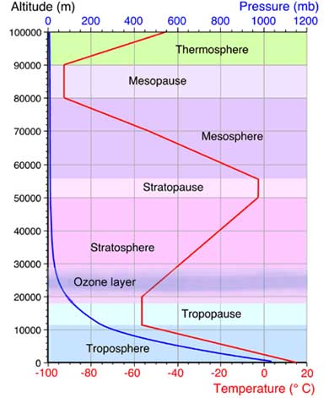](http://www.weatheronline.co.uk/reports/wxfacts/The-Earths-Atmosphere.htm)earth

Vegetation-affects both the temperature and precipitation patterns in an area

1. As latitude increases in the atmosphere what happens to temperature?

Depends on the layer of the atmosphere

1. Draw a diagram of the layers of the atmosphere.
2. What is the Köppen Climate Classification system based on?

Temperature and Precipitation